MODULE 4

Access Control (ACL):

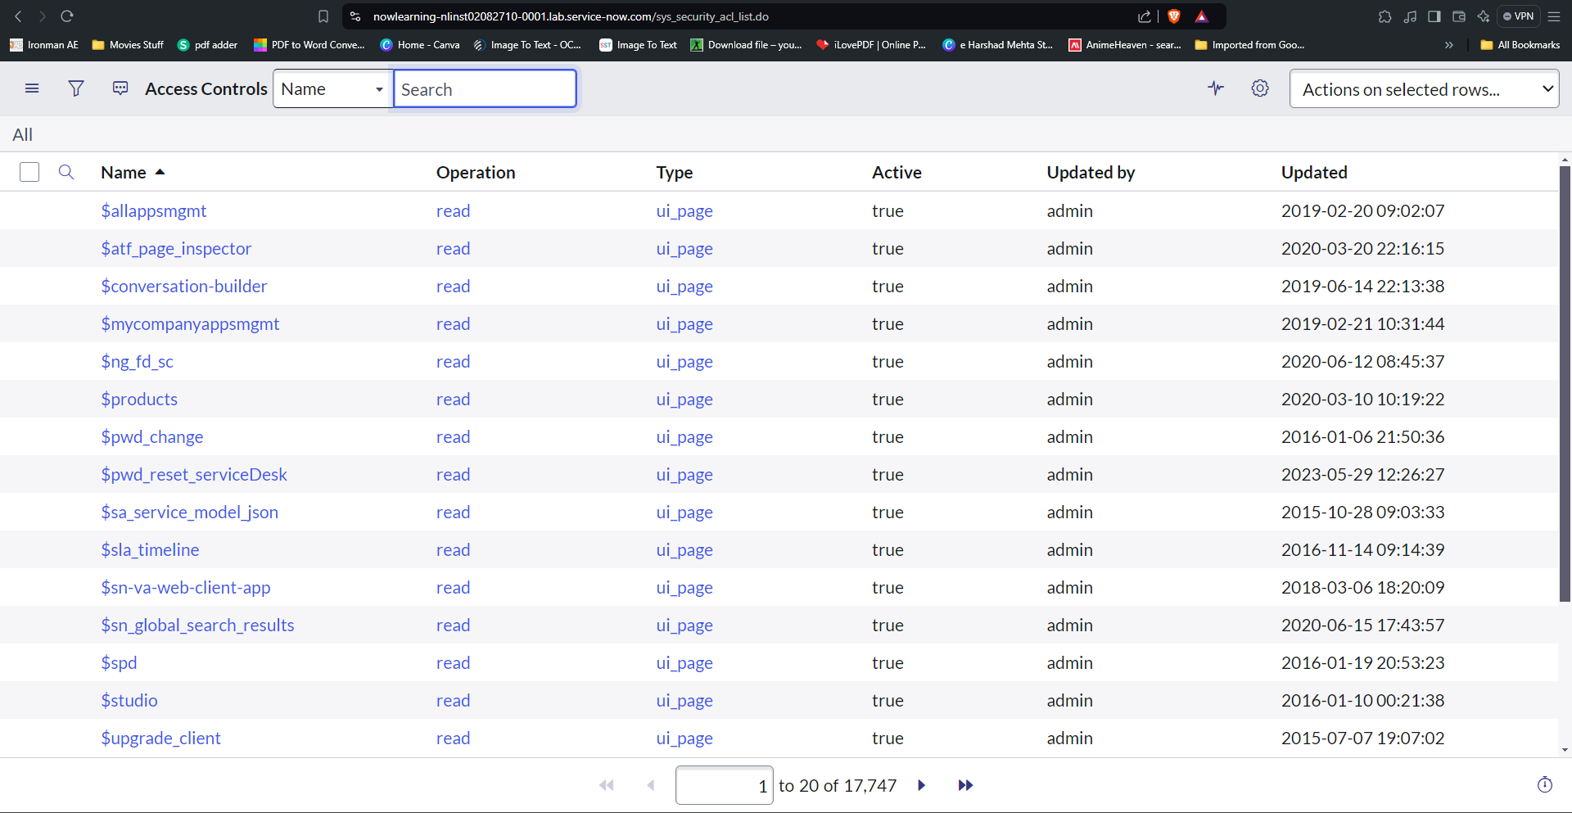

Creating Incident Model:

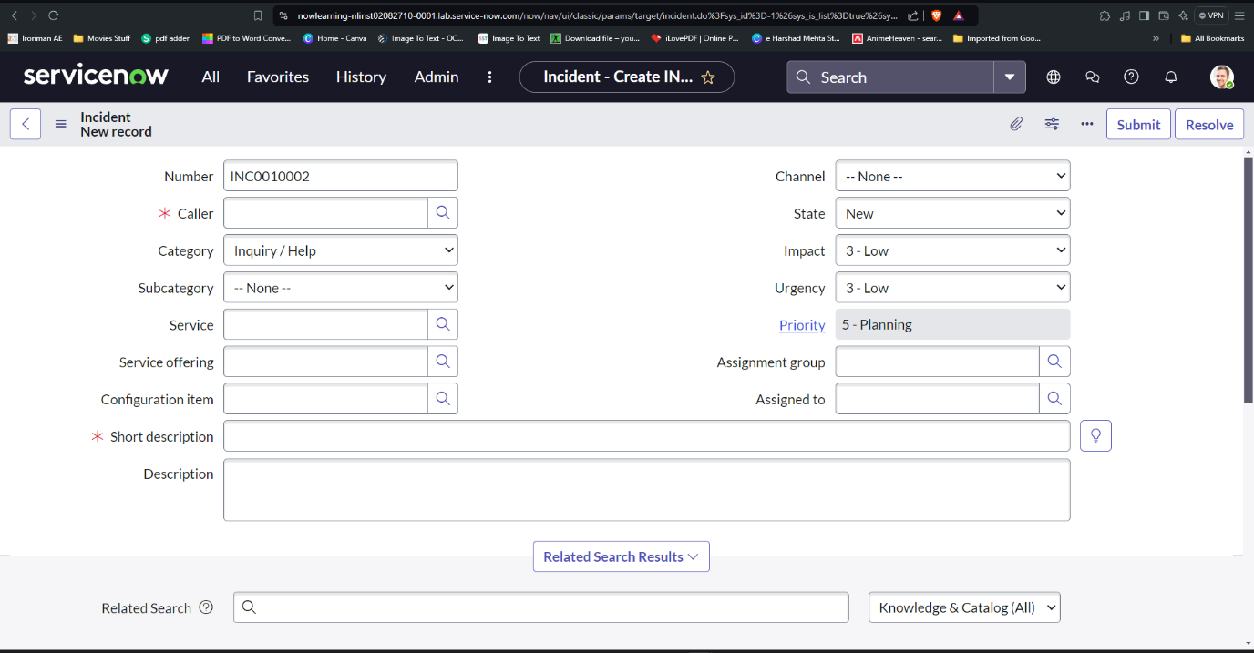

Maintain Items:

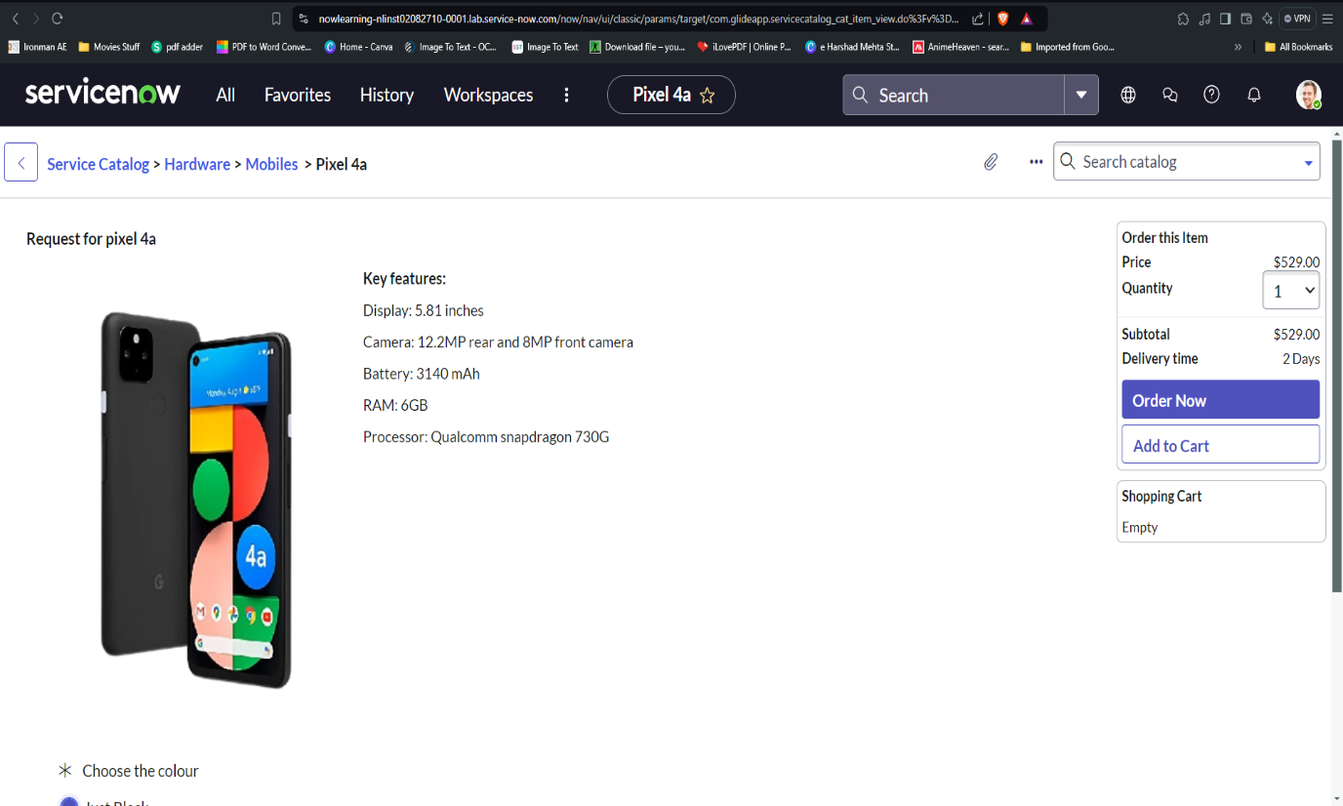

Fixing Script:

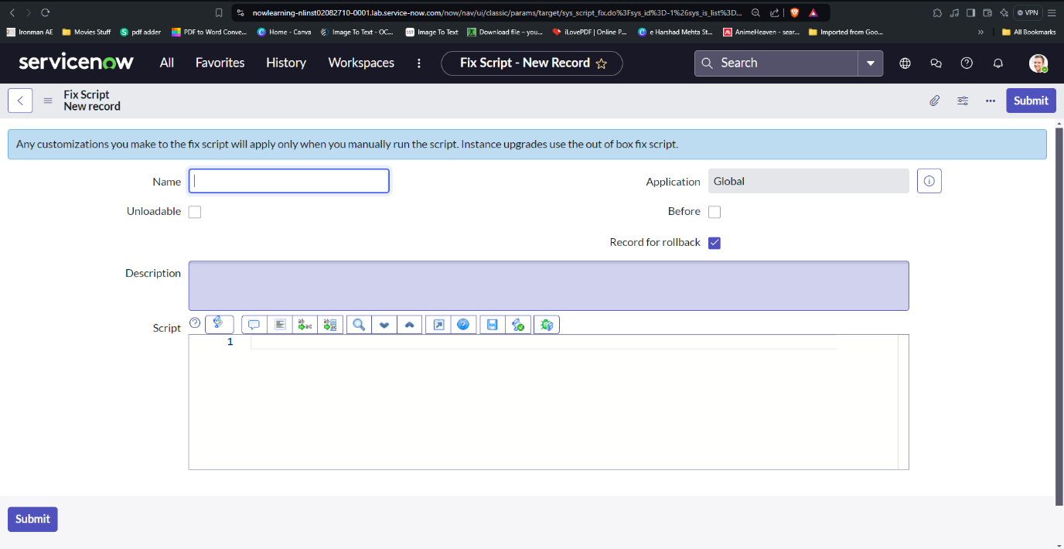

Understanding of how ServiceNow functions and how to properly configure and personalize the platform?

ServiceNow is a could based platform, which was mainly developed for workflow and process automation as per the ITIL principles. It is highly customisable and also can be used for other purposes.

**ServiceNow** was first introduced as ITSM tool used for various IT activities such as asset management, incident management, change management, problem management, Knowledge management, CMDB etc.

But, now ServiceNow becomes huge and serves lots of ITOM. ITBM applications like Project Portfolio management, Demand Management, Financial Management, Goverenance Risk and Compliance, HR, Agile Development and many more.

Services of ServiceNow:

* IT Service Management: Foundation of any kind of ServiceNow services. Incident problem change is focused.
* HR Management: HR(Human Resource) is a team which handles ServiceNow and the internal workforce that organizes the entire workflow. They deal with on-boarding and off-boarding of the resources. They take care of activities and functions inside the ServiceNow.
* GRC (Government Risk and Compliances): Analysing the risk involved in development and maintenance of compliances are done by GRC.
* Integrations: Integration is a place where a user can connect two systems together.
* IT Asset Management: Management of assets in IT sector like laptops, computers etc devices and objects are controlled by this sector.
* Finance Operation Management: This sector is similar to HR management, where they manage the finance.

IT Business Management: Dealing with business point of view and sharing of ideas on the business developments, ups and downs in the business.

Problem Module:

* A problem is a cause of one or more incidents.
* The process of managing the lifecycle of all the problems that arises or could arise in an IT service is called as Problem management.

Change Module:

* A change request contains details information regarding the change, like the reason for the change, the risk, the priority, the change type, and the change category.
* A systematic approach for controlling the life cycle of all changes, making it easier to make beneficial changes with less disruption to the IT services is called ServiceNow Change Management.

List:

* A list displays a set of records from a table.
* Users have the ability to search sort, filter and edit data in lists.
* Users can search, sort, filter and edit data in lists. Lists can be integrated into forms and can have sub-lists.
* The list interface includes a title bar, breadcrumbs and filters, columns of data, and a footer. Evert column in a list represents a field in the table.

Forms:

* A form is a content page that displays the fields and values of a single record in a database table.
* Forms have a 1 -column layout, a 2 -column layout, or a blend of both.